**WEEK-2 (SUPERSET ID-6412459)**

**PL/SQL,JUnit_Basic Testing,Mockito exercises &**

**SL4 Logging**

PL-SQL

# Exercise 1: Control Structures

**Scenario 1:** The bank wants to apply a discount to loan interest rates for customers above 60 years old.

* **Question:** Write a PL/SQL block that loops through all customers, checks their age, and if they are above 60, apply a 1% discount to their current loan interest rates.

**Scenario 2:** A customer can be promoted to VIP status based on their balance.

* **Question:** Write a PL/SQL block that iterates through all customers and sets a flag IsVIP to TRUE for those with a balance over $10,000.

**Scenario 3:** The bank wants to send reminders to customers whose loans are due within the next 30 days.

* **Question:** Write a PL/SQL block that fetches all loans due in the next 30 days and prints a reminder message for each customer.

### CODE:

#### SET SERVEROUTPUT ON; BEGIN

EXECUTE IMMEDIATE 'DROP TABLE loans'; EXCEPTION WHEN OTHERS THEN NULL; END;

#### / BEGIN

EXECUTE IMMEDIATE 'DROP TABLE customers';

#### EXCEPTION WHEN OTHERS THEN NULL; END;

/

CREATE TABLE customers ( cust_id NUMBER PRIMARY KEY, age NUMBER,

balance NUMBER, vip_flag VARCHAR2(5)

);

CREATE TABLE loans (

loan_id NUMBER PRIMARY KEY,

cust_id NUMBER, int_rate NUMBER, due_on DATE,

FOREIGN KEY (cust_id) REFERENCES customers(cust_id)

);

INSERT INTO customers VALUES (1, 65, 12000, 'FALSE');

INSERT INTO customers VALUES (2, 45, 8000, 'FALSE');

INSERT INTO customers VALUES (3, 70, 15000, 'FALSE');

INSERT INTO loans VALUES (101, 1, 10, TO_DATE('04-JUL-2025','DD-MON-YYYY'));

INSERT INTO loans VALUES (102, 2, 9, TO_DATE('01-SEP-2025','DD-MON-YYYY'));

INSERT INTO loans VALUES (103, 3, 8, TO_DATE('29-JUN-2025','DD-MON-YYYY')); COMMIT;

#### BEGIN

FOR loan_rec IN (

SELECT l.loan_id, l.cust_id, l.int_rate FROM loans l

JOIN customers c ON l.cust_id = c.cust_id WHERE c.age > 60

)

#### LOOP

UPDATE loans

SET int_rate = int_rate - 1

WHERE loan_id = loan_rec.loan_id;

#### DBMS_OUTPUT.PUT_LINE(

'Scenario 1: 1% interest discount applied on Loan ' || loan_rec.loan_id || ' (Customer ID ' || loan_rec.cust_id || ')'

);

#### END LOOP;

FOR cust_rec IN (

SELECT cust_id, balance FROM customers WHERE balance > 10000

#### ) LOOP

UPDATE customers SET vip_flag = 'TRUE'

WHERE cust_id = cust_rec.cust_id;

#### DBMS_OUTPUT.PUT_LINE(

' Scenario 2: VIP status set for Customer ' || cust_rec.cust_id || ' (Balance: $' || cust_rec.balance || ')'

);

#### END LOOP;

FOR due_rec IN (

SELECT loan_id, cust_id, due_on FROM loans

WHERE due_on BETWEEN SYSDATE AND SYSDATE + 30

#### ) LOOP

DBMS_OUTPUT.PUT_LINE(

'Scenario 3: Reminder - Loan ' || due_rec.loan_id ||

' for Customer ' || due_rec.cust_id ||

' is due on ' || TO_CHAR(due_rec.due_on, 'DD-MON-YYYY')

);

#### END LOOP; COMMIT; END;

/

### OUTPUT:

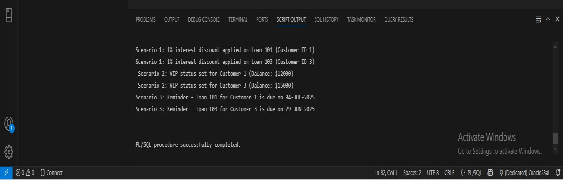

Scenario 1: 1% interest discount applied on Loan 101 (Customer ID 1)

Scenario 1: 1% interest discount applied on Loan 103 (Customer ID 3) Scenario 2: VIP status set for Customer 1 (Balance: $12000)

Scenario 2: VIP status set for Customer 3 (Balance: $15000)

Scenario 3: Reminder - Loan 101 for Customer 1 is due on 04-JUL-2025 Scenario 3: Reminder - Loan 103 for Customer 3 is due on 29-JUN-2025

PL/SQL procedure successfully completed.

# Exercise 3: Stored Procedures

**Scenario 1:** The bank needs to process monthly interest for all savings accounts.

* **Question:** Write a stored procedure **ProcessMonthlyInterest** that calculates and updates the balance of all savings accounts by applying an interest rate of 1% to the current balance.

**Scenario 2:** The bank wants to implement a bonus scheme for employees based on their performance.

* **Question:** Write a stored procedure **UpdateEmployeeBonus** that updates the salary of employees in a given department by adding a bonus percentage passed as a parameter.

**Scenario 3:** Customers should be able to transfer funds between their accounts.

* **Question:** Write a stored procedure **TransferFunds** that transfers a specified amount from one account to another, checking that the source account has sufficient balance before making the transfer.

### CODE:

#### SET SERVEROUTPUT ON; BEGIN

EXECUTE IMMEDIATE 'DROP TABLE accounts'; EXCEPTION WHEN OTHERS THEN NULL;

#### END;

/ BEGIN

EXECUTE IMMEDIATE 'DROP TABLE employees'; EXCEPTION WHEN OTHERS THEN NULL;

#### END;

/

CREATE TABLE accounts (

account_id NUMBER PRIMARY KEY, customer_id NUMBER,

balance NUMBER, account_type VARCHAR2(20)

);

CREATE TABLE employees (

emp_id NUMBER PRIMARY KEY, name VARCHAR2(50),

department VARCHAR2(50), salary NUMBER

);

INSERT INTO accounts VALUES (101, 1, 10000, 'SAVINGS');

INSERT INTO accounts VALUES (102, 2, 15000, 'CURRENT');

INSERT INTO accounts VALUES (103, 3, 20000, 'SAVINGS');

INSERT INTO employees VALUES (1, 'Ravi', 'Sales', 40000); INSERT INTO employees VALUES (2, 'Sneha', 'Finance', 45000); INSERT INTO employees VALUES (3, 'Ajith', 'Sales', 42000);

#### COMMIT;

CREATE OR REPLACE PROCEDURE ProcessMonthlyInterest IS BEGIN

UPDATE accounts

SET balance = balance + (balance * 0.01) WHERE UPPER(account_type) = 'SAVINGS';

DBMS_OUTPUT.PUT_LINE('Interest applied to all savings accounts.'); COMMIT;

#### END;

/

CREATE OR REPLACE PROCEDURE UpdateEmployeeBonus ( p_dept IN VARCHAR2,

p_bonus_pct IN NUMBER

#### ) IS BEGIN

UPDATE employees

SET salary = salary + (salary * p_bonus_pct / 100) WHERE LOWER(department) = LOWER(p_dept);

DBMS_OUTPUT.PUT_LINE('Bonus of ' || p_bonus_pct || '% applied to ' || p_dept

|| ' department.'); COMMIT;

#### END;

/

CREATE OR REPLACE PROCEDURE TransferFunds (

p_from_account IN NUMBER, p_to_account IN NUMBER, p_amount IN NUMBER

#### ) IS

v_balance NUMBER;

#### BEGIN

SELECT balance INTO v_balance FROM accounts

WHERE account_id = p_from_account;

IF v_balance < p_amount THEN

RAISE_APPLICATION_ERROR(-20001, 'Not enough balance in source account.');

#### END IF;

UPDATE accounts

SET balance = balance - p_amount WHERE account_id = p_from_account;

UPDATE accounts

SET balance = balance + p_amount WHERE account_id = p_to_account;

DBMS_OUTPUT.PUT_LINE('₹' || p_amount || ' transferred from Account ' ||

p_from_account || ' to Account ' || p_to_account); COMMIT;

#### END;

/ BEGIN

DBMS_OUTPUT.PUT_LINE('----- Executing ProcessMonthlyInterest ');

ProcessMonthlyInterest;

DBMS_OUTPUT.PUT_LINE('----- Executing UpdateEmployeeBonus (Sales, 10%) ');

UpdateEmployeeBonus('Sales', 10);

DBMS_OUTPUT.PUT_LINE('----- Executing TransferFunds (103 -> 102 ₹2000) ');

TransferFunds(103, 102, 2000); END;

**OUTPUT**

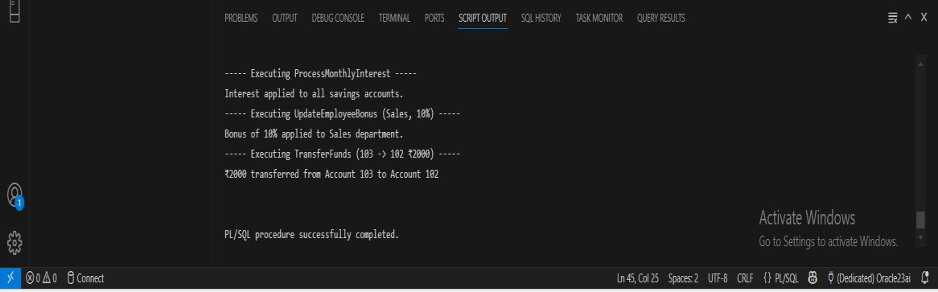

JUnit Basic Testing

# Exercise 1: Setting Up JUnit

Scenario:

You need to set up JUnit in your Java project to start writing unit tests. Steps:

1. Create a new Java project in your IDE (e.g., IntelliJ IDEA, Eclipse).
2. Add JUnit dependency to your project. If you are using Maven, add the following to your

pom.xml:

<dependency>

<groupId>junit</groupId>

<artifactId>junit</artifactId>

<version>4.13.2</version>

<scope>test</scope>

</dependency>

1. Create a new test class in your project

CODE:

## Calculator.java

package com.example;

public class Calculator { public int add(int a, int b) {

System.out.println("Adding numbers: " + a + " + " + b); int result = a + b;

System.out.println("Computed result: " + result); return result;

}

public int subtract(int a, int b) { System.out.println("Subtracting numbers: " + a + " - " + b); int result = a - b;

System.out.println("Computed result: " + result); return result;

}

public int multiply(int a, int b) { System.out.println("Multiplying numbers: " + a + " * " + b); int result = a * b;

System.out.println("Computed result: " + result); return result;

}

}

## CalculatorTest.java

package com.example; import org.junit.Test;

import static org.junit.Assert.*; public class CalculatorTest { @Test

public void testAdd() {

Calculator calc = new Calculator(); System.out.println("---- Testing add() ");

int result = calc.add(2, 3); assertEquals(5, result);

System.out.println("Test add() passed.\n");

}

@Test

public void testSubtract() { Calculator calc = new Calculator();

System.out.println("---- Testing subtract() ");

int result = calc.subtract(10, 4); assertEquals(6, result);

System.out.println("Test subtract() passed.\n");

}

@Test

public void testMultiply() { Calculator calc = new Calculator();

System.out.println("---- Testing multiply() ");

int result = calc.multiply(3, 4); assertEquals(12, result);

System.out.println("Test multiply() passed.\n");

**OUTPUT:**

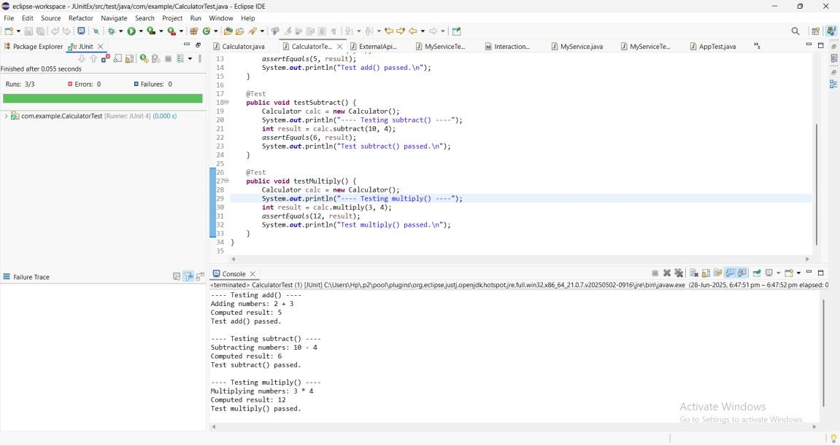

# Exercise 3: Assertions in JUnit

Scenario:

You need to use different assertions in JUnit to validate your test results. Steps: 1. Write tests using various JUnit assertions.

Solution Code:

public class AssertionsTest { @Test

public void testAssertions() {

// Assert equals assertEquals(5, 2 + 3);

// Assert true assertTrue(5 > 3);

// Assert false assertFalse(5 < 3);

// Assert null assertNull(null);

// Assert not null assertNotNull(new Object());

}

}

CODE:

**AssertionsTest.java** package com.example; import org.junit.Test;

import static org.junit.Assert.*; public class AssertionsTest { @Test

public void testAssertions() {

assertEquals(5, 2 + 3); System.out.println("assertEquals passed"); assertTrue(5 > 3); System.out.println("assertTrue passed"); assertFalse(5 < 3); System.out.println("assertFalse passed"); assertNull(null); System.out.println("assertNull passed"); assertNotNull(new Object()); System.out.println("assertNotNull passed");

}

}

**OUTPUT:**

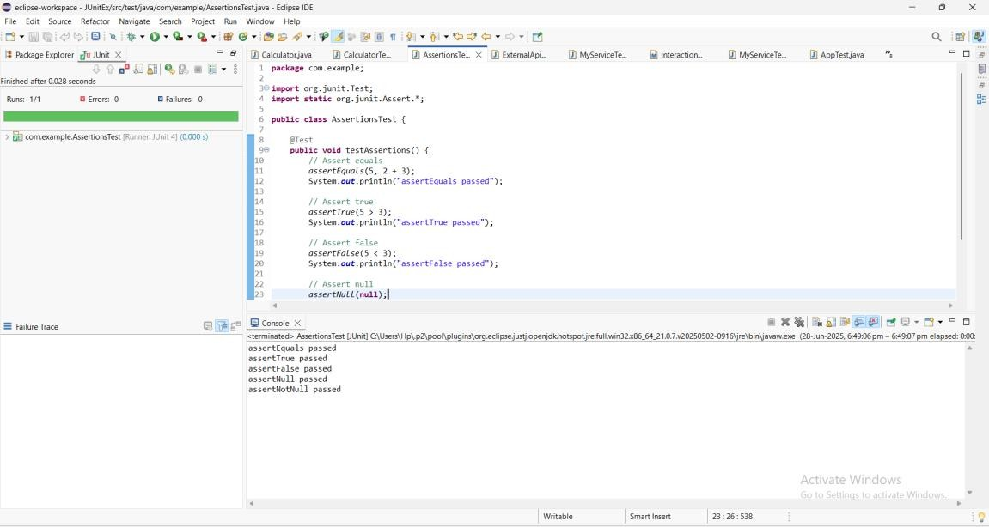

## Exercise 4: Arrange-Act-Assert (AAA) Pattern, Test Fixtures, Setup and Teardown Methods in JUnit

Scenario:

You need to organize your tests using the Arrange-Act-Assert (AAA) pattern and use setup

and teardown methods. Steps:

1. Write tests using the AAA pattern.
2. Use @Before and @After annotations for setup and teardown methods.

CODE:

### CalculatorTestAAA.java

package com.example;

import org.junit.Before; import org.junit.After; import org.junit.Test;

import static org.junit.Assert.*; public class CalculatorTestAAA { private Calculator calculator;

@Before

public void setUp() { calculator = new Calculator();

System.out.println("setUp: Calculator instance created");

}

@After

public void tearDown() { System.out.println("tearDown: Test completed\n");

}@Test

public void testAddition() { int a = 10;

int b = 5;

int result = calculator.add(a, b); assertEquals(15, result);

System.out.println("testAddition: " + a + " + " + b + " = " + result);

}

@Test

public void testSubtraction() { int a = 8;

int b = 3;

int result = calculator.subtract(a, b); assertEquals(5, result);

System.out.println("testSubtraction: " + a + " - " + b + " = " + result);

}

**OUTPUT:**

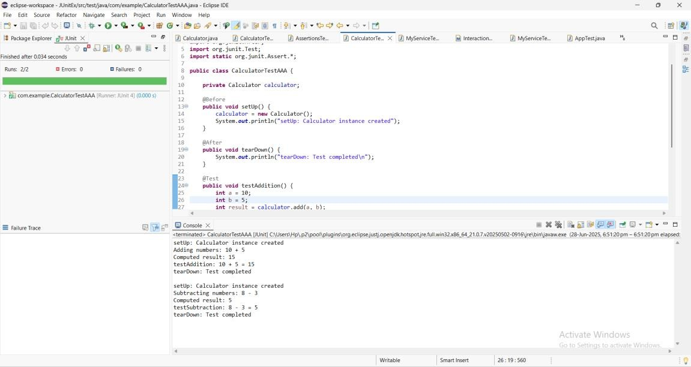

# Mockito Hands-On Exercises

## Exercise 1: Mocking and Stubbing

Scenario:

You need to test a service that depends on an external API. Use Mockito to mock the external API and stub its methods.

Steps:

1. Create a mock object for the external API.
2. Stub the methods to return predefined values.
3. Write a test case that uses the mock object.

Solution Code:

import static org.mockito.Mockito.*; import org.junit.jupiter.api.Test; import org.mockito.Mockito;

public class MyServiceTest { @Test

public void testExternalApi() {

ExternalApi mockApi = Mockito.mock(ExternalApi.class); when(mockApi.getData()).thenReturn("Mock Data"); MyService service = new MyService(mockApi);

String result = service.fetchData(); assertEquals("Mock Data", result);

}

CODE:

## ExternalApi.java

package com.example.MockDemo; public interface ExternalApi { String getData();

}

## Myservice.java

package com.example.MockDemo;

public class MyService {

private final ExternalApi externalApi;

public MyService(ExternalApi externalApi) { this.externalApi = externalApi;

}

public String fetchData() { return externalApi.getData();

}

}

## MyServiceTest.java

package com.example.MockDemo;

import org.junit.jupiter.api.Test;

import static org.junit.jupiter.api.Assertions.assertEquals; import static org.mockito.Mockito.*;

public class MyServiceTest {

@Test

public void testFetchData() {

// Arrange (Mock setup)

ExternalApi mockApi = mock(ExternalApi.class); when(mockApi.getData()).thenReturn("Mock Data");

MyService service = new MyService(mockApi); String result = service.fetchData(); assertEquals("Mock Data", result);

System.out.println("Test passed. Returned: " + result);

}

}

**OUTPUT:**

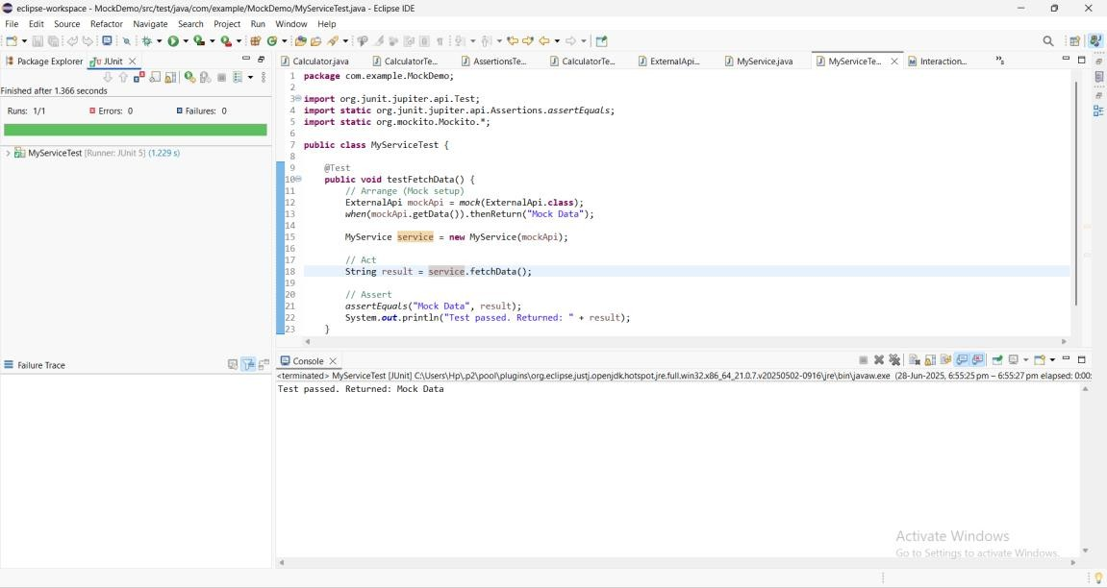

# Exercise 2: Verifying Interactions

Scenario:

You need to ensure that a method is called with specific arguments. Steps:

1. Create a mock object.
2. Call the method with specific arguments.
3. Verify the interaction. Solution Code:

import static org.mockito.Mockito.*; import org.junit.jupiter.api.Test;

import org.mockito.Mockito; public class MyServiceTest { @Test

public void testVerifyInteraction() {

ExternalApi mockApi = Mockito.mock(ExternalApi.class); MyService service = new MyService(mockApi); service.fetchData();

verify(mockApi).getData();

CODE:

## ExternalApi.java

package com.example.InteractionVerifier;

public interface ExternalApi { String getData();

}

## MyService.java

package com.example.InteractionVerifier;

public class MyService {

private ExternalApi externalApi;

public MyService(ExternalApi externalApi) { this.externalApi = externalApi;

}

public String fetchData() { return externalApi.getData();

}

}

## MyServiceTest.java

package com.example.InteractionVerifier;

import org.junit.jupiter.api.Test;

import static org.junit.jupiter.api.Assertions.assertEquals; import static org.mockito.Mockito.*;

public class MyServiceTest {

@Test

public void testVerifyInteraction() {

ExternalApi mockApi = mock(ExternalApi.class); when(mockApi.getData()).thenReturn("Mocked Interaction Data");

MyService service = new MyService(mockApi);

String result = service.fetchData(); assertEquals("Mocked Interaction Data", result); System.out.println("fetchData() returned: " + result);

verify(mockApi).getData();

System.out.println("Verified that getData() was called on mock");

}

}

**OUTPUT:**

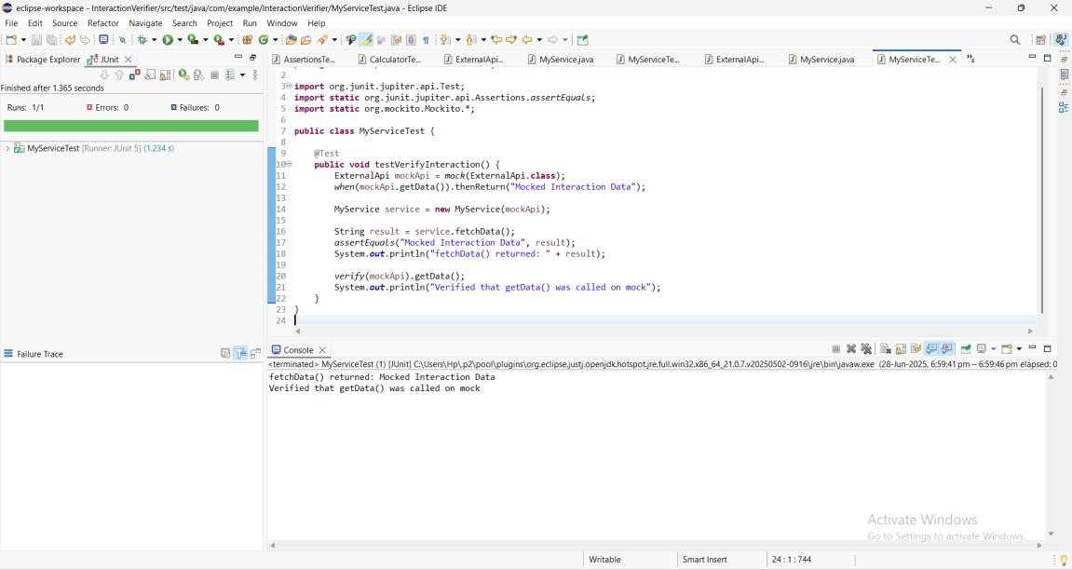

**Logging using SLF4J**

# Exercise 1: Logging Error Messages and Warning Levels

Task: Write a Java application that demonstrates logging error messages and warning levels

using SLF4J.

Step-by-Step Solution:

1. Add SLF4J and Logback dependencies to your `pom.xml` file:

<dependency>

<groupId>org.slf4j</groupId>

<artifactId>slf4j-api</artifactId>

<version>1.7.30</version>

</dependency>

<dependency>

<groupId>ch.qos.logback</groupId>

<artifactId>logback-classic</artifactId>

<version>1.2.3</version>

</dependency>

1. Create a Java class that uses SLF4J for logging:

import org.slf4j.Logger;

import org.slf4j.LoggerFactory; public class LoggingExample {

private static final Logger logger = LoggerFactory.getLogger(LoggingExample.class); public static void main(String[] args) {

logger.error("This is an error message"); logger.warn("This is a warning message");

}

}

CODE:

## LoggingExample.java

package com.example.LoggingDemonew; import org.slf4j.Logger;

import org.slf4j.LoggerFactory; public class LoggingExample {

private static final Logger logger = LoggerFactory.getLogger(LoggingExample.class); public static void main(String[] args) {

logger.error("This is an ERROR message"); logger.warn("This is a WARNING message"); logger.info("This is an INFO message"); logger.debug("This is a DEBUG message");

}

}

**OUTPUT:**

